

Semester One Examination, 2021

Question/Answer booklet

MATHEMATICS APPLICATIONS  
UNIT 3

Section Two: Calculator-assumed

Your name _________________________

Circe your teacher’s name **MOYLE** **SULESKI**

## Time allowed for this section

Reading time before commencing work: ten minutes

Working time: one hundred minutes

## Materials required/recommended for this section

***To be provided by the supervisor***

This Question/Answer booklet

Formula sheet (retained from Section One)

***To be provided by the candidate***

Standard items: pens (blue/black preferred), pencils (including coloured), sharpener,  
correction fluid/tape, eraser, ruler, highlighters

Special items: drawing instruments, templates, notes on one unfolded sheet of A4 paper, and up to three calculators, which can include scientific, graphic and Computer Algebra System (CAS) calculators, are permitted in this ATAR course examination

## Important note to candidates

No other items may be taken into the examination room. It is **your** responsibility to ensure that you do not have any unauthorised material. If you have any unauthorised material with you, hand it to the supervisor **before** reading any further.

## Structure of this paper

|  |  |  |  |  |  |
| --- | --- | --- | --- | --- | --- |
| Section | Number of questions available | Number of questions to be answered | Working time (minutes) | Marks available | Percentage of examination |
| Section One: Calculator-free | 8 | 8 | 50 | 51 | 35 |
| Section Two: Calculator-assumed | 13 | 13 | 100 | 98 | 65 |
|  | | |  | **Total** | 100 |

## Instructions to candidates

1. The rules for the conduct of examinations are detailed in the school handbook. Sitting this examination implies that you agree to abide by these rules.

2. Write your answers in this Question/Answer booklet preferably using a blue/black pen.  
Do not use erasable or gel pens.

3. You must be careful to confine your answers to the specific question asked and to follow any instructions that are specific to a particular question.

4. Show all your working clearly. Your working should be in sufficient detail to allow your answers to be checked readily and for marks to be awarded for reasoning. Incorrect answers given without supporting reasoning cannot be allocated any marks. For any question or part question worth more than two marks, valid working or justification is required to receive full marks. If you repeat any question, ensure that you cancel the answer you do not wish to have marked.

5. It is recommended that you do not use pencil, except in diagrams.

6. Supplementary pages for planning/continuing your answers to questions are provided at the end of this Question/Answer booklet. If you use these pages to continue an answer, indicate at the original answer where the answer is continued, i.e. give the page number.

7. The Formula sheet is not to be handed in with your Question/Answer booklet.

Section Two: Calculator-assumed 65% (98 Marks)

This section has**thirteen** questions. Answer **all** questions. Write your answers in the spaces provided.

Working time: 100 minutes.

Question 9 (7 marks)

A grain silo stood empty at the start of a harvest. Over the next month, the weight of barley in the silo, $W_{n}$ tonnes at the end of the $n^{th}$ day, was modelled by $W_{n+1}=0.8W_{n}+36, W_{0}=0$.

(a) Determine, to the nearest tonne, the change in the weight of barley in the silo from the end of day $2$ to the end of day $6$. (3 marks)

(b) At the end of which day did the weight of barley in the silo first exceed $175$ tonnes?

(1 mark)

(c) Eventually, the weight of barley will reach a steady state. At the end of which day did the weight of barley in the silo first come within a quarter of a tonne of the steady state? Justify your answer. (3 marks)

Question 10 (7 marks)

The vertices $A$ to $G$ in the graph below represent major bus stations in a city and the edge weights represent the travel time between pairs of stations in minutes.

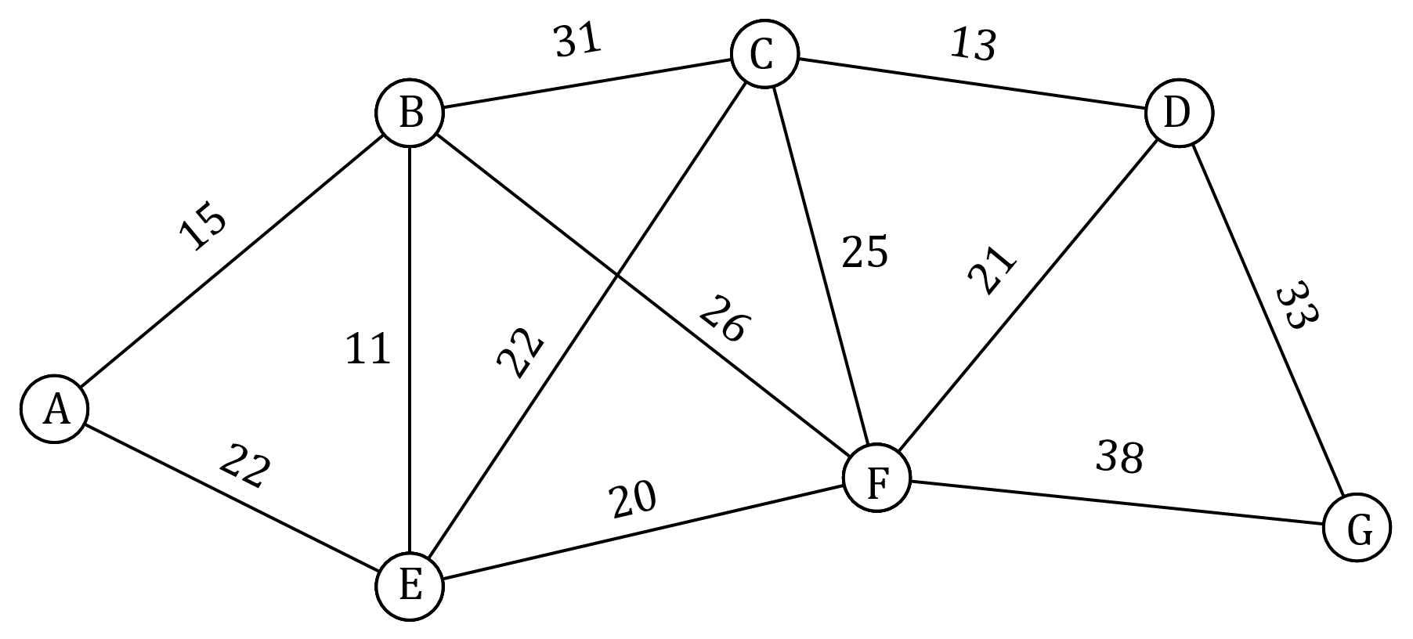

(a) Determine the minimum travel time and corresponding route between the following pairs of stations:

(i) $D$ and $E$. (2 marks)

(ii) $A$ and $G$. (3 marks)

(b) It is possible to reduce the travel time between stations $E$ and $F$. Determine the reduction required so that the current minimum travel time between stations $B$ and $G$ is equal to the minimum travel time between these stations, via station $E$, after the reduction.

(2 marks)

Question 11 (8 marks)

Participants at an educational conference were categorised by district they worked in and main area of interest. The table below shows the number of participants in these categories.

|  |  |  |  |  |
| --- | --- | --- | --- | --- |
|  |  | Main area of interest | | |
|  |  | Primary | Secondary | Tertiary |
| District | Metropolitan | $$59$$ | $$67$$ | $$37$$ |
| Regional | $$32$$ | $$36$$ | $$19$$ |

(a) Determine what percentage of participants

(i) had primary as their main area of interest. (2 marks)

(ii) worked in the metropolitan district. (1 mark)

(b) Use the above table to complete the following table of row percentages, rounding entries to the nearest whole number. (3 marks)

|  |  |  |  |
| --- | --- | --- | --- |
| (%) | Primary | Secondary | Tertiary |
| Metropolitan |  |  |  |
| Regional |  |  |  |

(c) Explain whether the percentaged table above suggest the presence of an association between district worked in and main area of interest for the participants. (2 marks)

Question 12 (8 marks)

The following table shows the compressive strength, in megapascals, achieved by concrete after one week for different water-cement ratios, as a percentage, used in its mixture.

|  |  |  |  |  |  |  |  |
| --- | --- | --- | --- | --- | --- | --- | --- |
| Water-cement ratio $R, \%$ | $$40$$ | $$44$$ | $$47$$ | $$51$$ | $$53$$ | $$56$$ | $$60$$ |
| Strength $S$, MPa | $$26.4$$ | $$24.8$$ | $$21.0$$ | $$20.1$$ | $$19.0$$ | $$19.3$$ | $$15.1$$ |

(a) Determine the equation of the least-squares line for the data, with ratio $R$ as the explanatory variable. (2 marks)

(b) In the context of the question, interpret the slope of the least-squares line in part (a).

(2 marks)

(c) State the coefficient of determination and use it to assess the strength of the linear association. (2 marks)

(d) Predict the value of the strength $S$ when the water-cement ratio is $42\%$ and discuss the validity of this prediction. (2 marks)

Question 13 (7 marks)

The balance $A_{n}$ of an account after $n$ years, in dollars, is modelled by the recurrence relation $A_{n+1}=1.18A_{n}, A_{0}=150$.

(a) Determine the balance of the account, to the nearest cent, after

(i) $2$ years. (1 mark)

(ii) $8$ years. (1 mark)

(b) Plot $A_{n}$ on the axes below for $n=0$ to $n=8$. (3 marks)

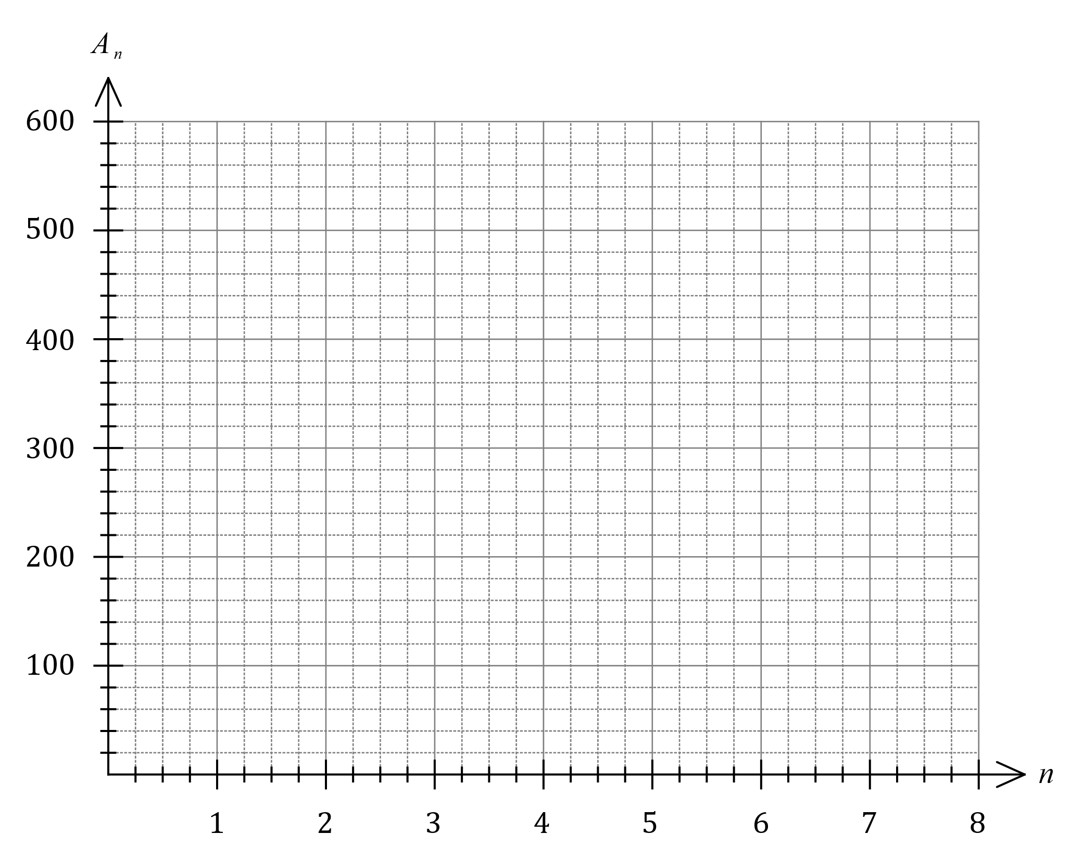

(c) Describe the features of the graph in part (b) that illustrate the exponential growth of the balance. (2 marks)

Question 14 (7 marks)

An unmanned submarine has to return directly to its host ship, currently at anchor and $120$ km away from the submarine. With failing batteries, the submarine can travel $18$ km in the first hour, $16.5$ km in the second hour and so on, always $1.5$ km less than in the previous hour until it no longer moves.

(a) Determine the total distance travelled by the submarine in the first three hours. (2 marks)

(b) Determine a simplified rule for the distance $D_{n}$ travelled by the submarine in the $n^{th}$ hour. (2 marks)

(c) At the start of which hour will the submarine no longer move? (1 mark)

(d) State, with reasons, whether the submarine will reach its host ship. (2 marks)

Question 15 (7 marks)

A student found a box containing three keys and four padlocks. Some keys will open more than one padlock. A tick in the following table indicates that a key will open that padlock.

|  |  |  |  |  |
| --- | --- | --- | --- | --- |
|  |  | Key | | |
|  |  | 1 | 2 | 3 |
| Padlock | A | ✓ | ✓ |  |
| B | ✓ |  | ✓ |
| C |  | ✓ | ✓ |
| D | ✓ | ✓ |  |

(a) Represent this information clearly as a bipartite graph $G$. (3 marks)

(b) The presence of exactly two odd vertices in $G$ indicates that it is semi-Eulerian. State the definition of a semi-Eulerian graph. (2 marks)

(c) If another edge was added to $G$, from one odd vertex to the other, state, with reasons, whether $G$ is still:

(i) bipartite. (1 mark)

(ii) semi-Eulerian. (1 mark)

Question 16 (9 marks)

The table and graph below shows the average fuel consumption, in litres per $100$ km, achieved by the drivers of different cars before and after they took part in an advanced driving course.

|  |  |  |  |  |  |  |  |  |  |  |
| --- | --- | --- | --- | --- | --- | --- | --- | --- | --- | --- |
| Before $x$ | $$7.5$$ | $$6.7$$ | $$9.3$$ | $$11.3$$ | $$8.8$$ | $$12.7$$ | $$11.9$$ | $$9.1$$ | $$10.5$$ | $$9.7$$ |
| After $y$ | $$7.3$$ | $$6.5$$ | $$9.6$$ | $$11.2$$ | $$7.9$$ | $$12.3$$ | $$11.5$$ | $$8.5$$ | $$10.2$$ | $$9.2$$ |

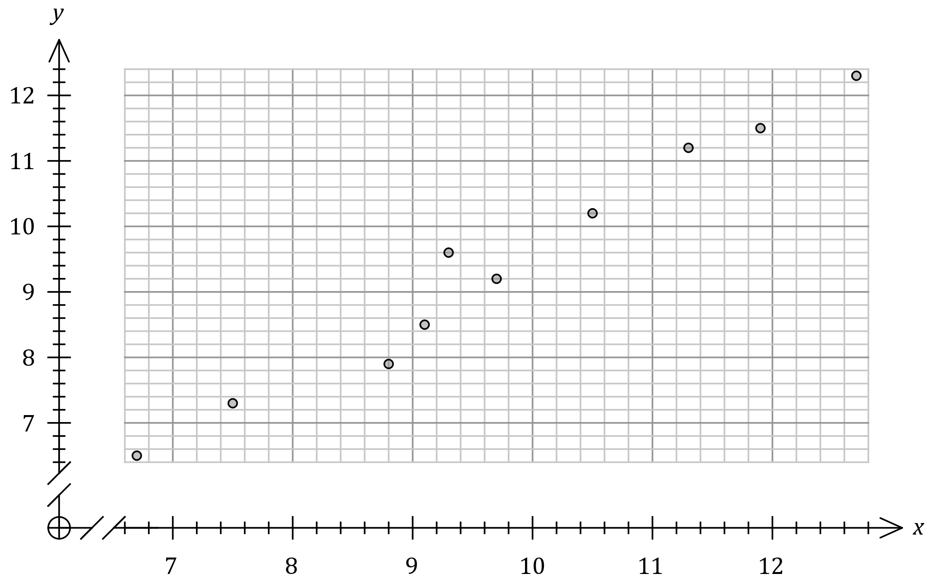

(a) Use the above information to determine

(i) the correlation coefficient $r_{xy}$. (1 mark)

(ii) the equation of the least-squares line of $y$ on $x$. (2 marks)

(b) Draw the least-squares line on the graph above. (2 marks)

(c) The fuel consumption achieved by the driver of another car was $13.5$ litres per $100$ km before they took part in the course.

(i) Predict the fuel consumption this driver will achieve after the course. (1 mark)

(ii) Explain why the correlation coefficient supports confidence in the above prediction.

(1 mark)

(iii) Explain why this prediction involves extrapolation and how this affects confidence in the above prediction. (2 marks)

Question 17 (7 marks)

Graph $G$ has $5$ vertices with degrees $2, 2, 3, 3$ and $4$.

(a) Determine the number of edges that $G$ has. (2 marks)

(b) Draw $G$ in the plane as a simple connected graph and state the number of faces it has.

(3 marks)

(c) Draw $G$ in the plane as a connected graph with one bridge. (2 marks)

Question 18 (8 marks)

(a) The value of a painting, initially worth $\$2500$, increases by a $7\%$ of its value each year.

(i) Deduce the $n^{th}$ term rule for the value $V_{n}$ of the painting after $n$ years. (2 marks)

(ii) Determine the number of years until the painting is first worth more than $\$6 000$.

(1 mark)

(b) The value of a machine decreases by a fixed percentage of its value each year, so that after $3$ years it has a value of $\$2947.80$ and after $4$ years it has a value of $\$2505.63$.

(i) Determine the fixed percentage. (2 marks)

(ii) Determine the initial value of the machine. (3 marks)

Question 19 (7 marks)

A person has decided to deposit $\$40$ every month into their savings account. Interest at a rate of $0.25\%$ of the balance will be added to the account just before each deposit is made.

The recurrence relation $A_{n+1}=1.0025A_{n}+40, A_{0}=1800$ can be used to model the balance of the savings account, where $A_{n}$ is the balance in dollars after $n$ deposits.

(a) Determine

(i) the initial balance of the account. (1 mark)

(ii) the balance of the account after $12$ deposits. (1 mark)

(iii) the number of months it would take for the account balance to first exceed double its initial balance. (2 marks)

(b) If, after the ${15}^{th}$ deposit, the interest rate decreased from $0.25\%$ to $0.22\%$ and the monthly deposit increased from $\$40$ to $\$55$, determine the account balance after a further $12$ deposits have been made. (3 marks)

Question 20 (8 marks)

The linear model fitted to a data set had equation $\hat{y}=18.86x-120.9$. The correlation coefficient between the variables was $r_{xy}=0.977$. The residual plot for the linear model is shown below.

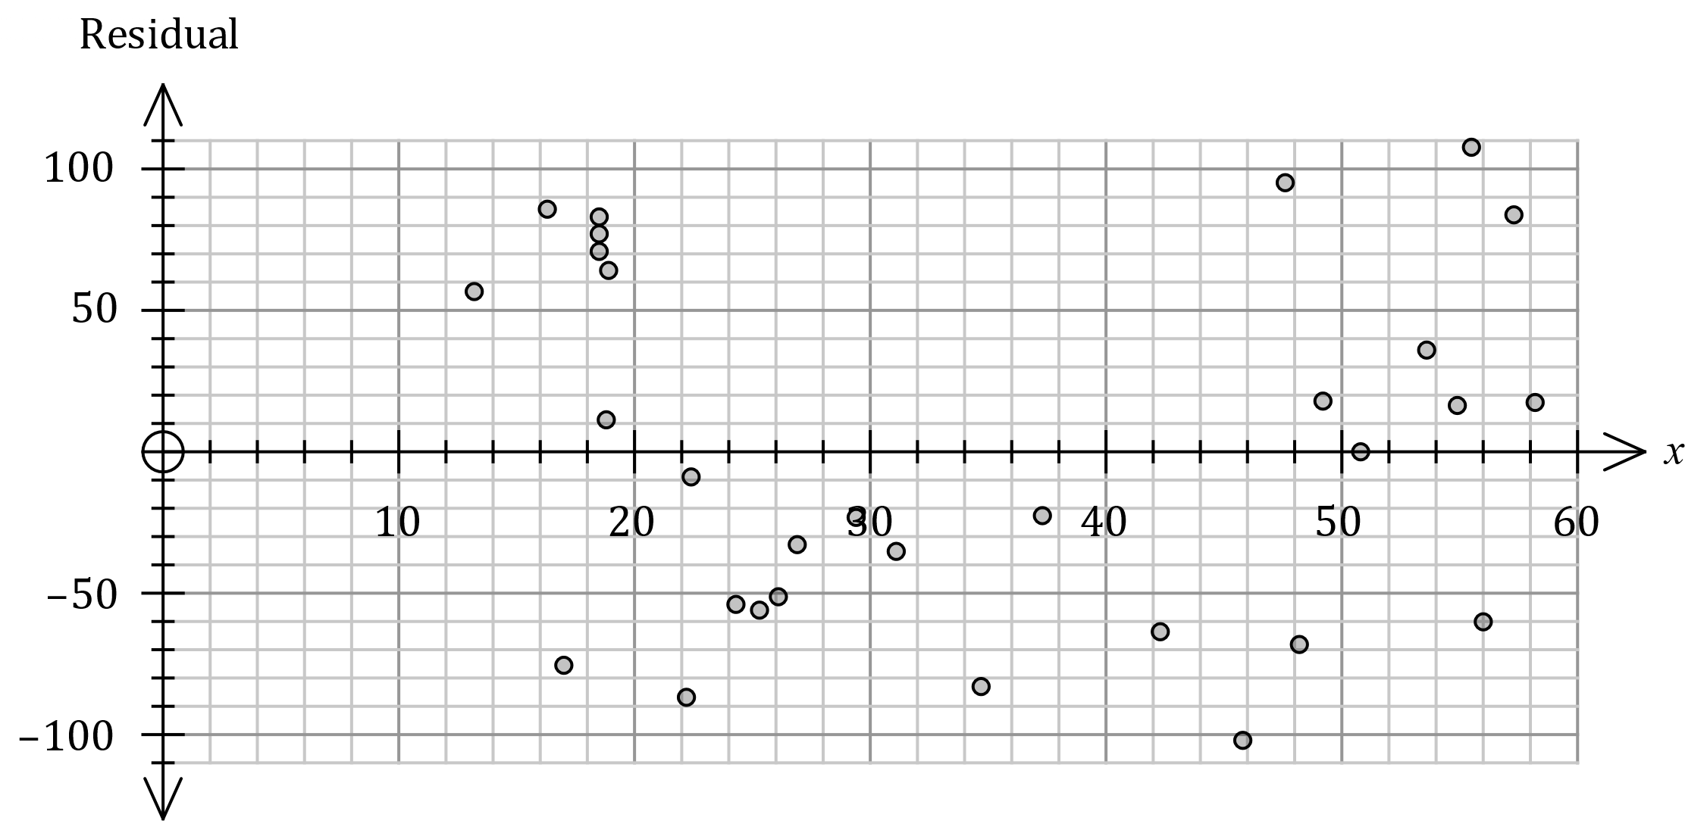

(a) The residual for the data point $(45, 745)$ is not shown. Determine the residual for this point and add it to the residual plot. (3 marks)

(b) Use the residual plot to assess the appropriateness of fitting a linear model to the data.

(2 marks)

(c) The point shown on the plot above with a residual of $-76.7$ was derived from the data point $x=a, y=b$. Determine the value of $a$ and the value of $b$. (3 marks)

Question 21 (8 marks)

The vertices in graph $G_{1}$ below represent towns, the edges represent roads, and each edge weight represents the length of the road between adjacent towns in kilometres.

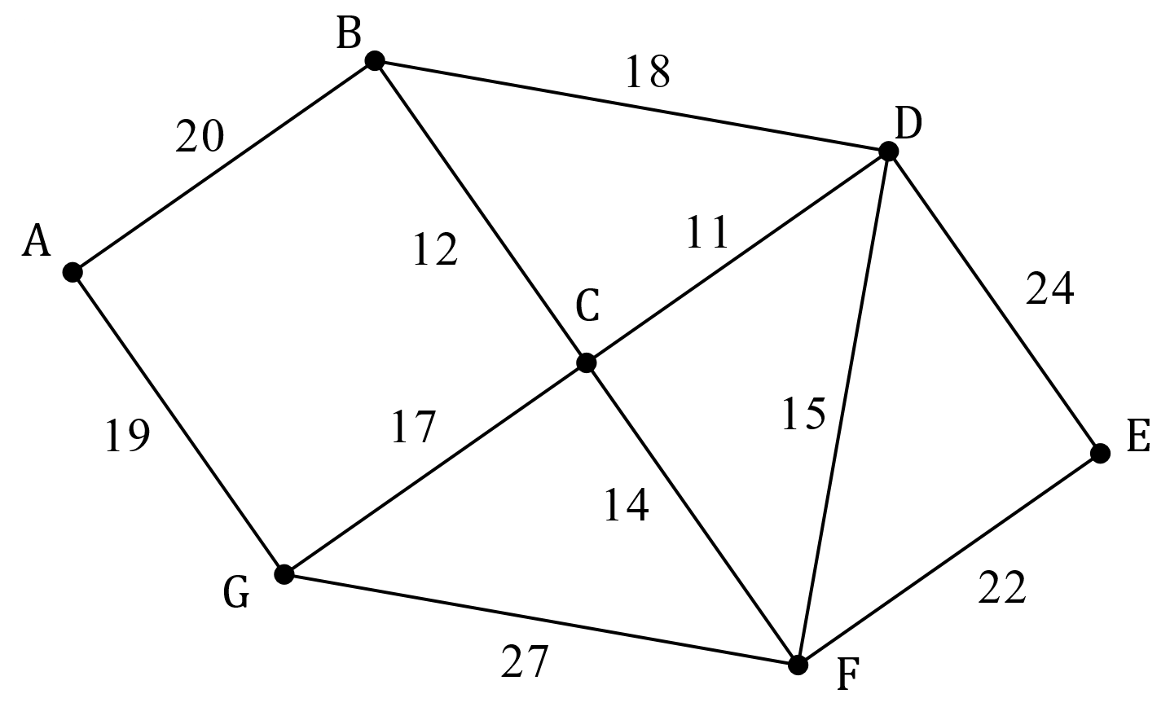

(a) List, starting with $A$ and in the order visited, the vertices that lie on the Hamiltonian cycle with the minimum total road length and state this minimum length. (3 marks)

An engineer must drive an inspection vehicle along the entire length of all $11$ roads in $G_{1}$.

(b) State, with justification, where the inspection should start and where it should finish to minimise the distance that the engineer must drive. (2 marks)

(c) For practical reasons, the engineer has to start at town $A$ and must return there at the end of the inspection. Determine, with reasoning, the minimum distance the engineer must drive. A copy of $G_{1}$ is provided below. (3 marks)



Supplementary page

Question number: _________

Supplementary page

Question number: _________